Theoretical and practical aspects of East European development aid to Africa during the Cold War era

University of Warsaw, 20-21 November 2025

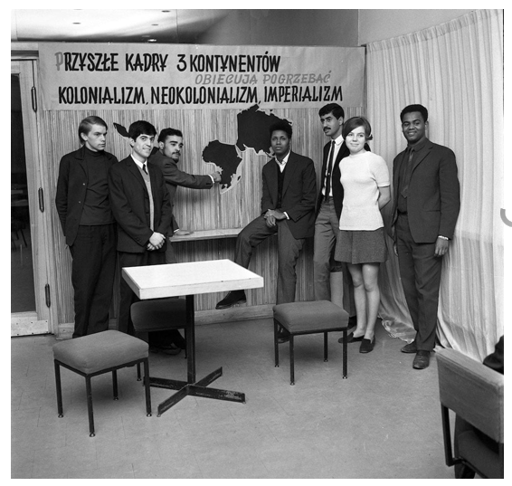
Source: New East Archive (https://www.new-east-archive.org)

Thursday, November 20
Audytorium Maximum, aula D
ul. Krakowskie Przedmieście 26/28

9.45 – 10.00 | Opening remarks

10.00 – 11.30 | Multilateralism, regional cooperation, and Socialist bilateralism
Michael Tshinyalani Khorommbi (Stellenbosch University), Competing Solidarities: Eastern European Aid Rivalries and African Agency under the Council for Mutual Economic Assistance (1961–1988)
Barbora Buzássyová (Slovak Academy of Sciences), Trading Solidarity: Czechoslovakia, UNESCO and Educational Aid to sub-Saharan Africa from the 1960s and beyond
Sarah Marks (University of London, UK), Czechoslovak Health Aid to Ethiopia during the Selassie Period

11.30 – 11.50 | Coffee break

11.50 – 13.00 | Eastern European Development Aid and Local Perspective
Sarah Howard (University of Bristol), Socialist childcare between Ethiopia and Eastern Europe from 1974
Bharti Chhibber (University of Delhi), Policy in Practice: Eastern European Development Aid and African Women’s Empowerment

13.00-14.30 | Lunch break

14.30 – 16.00 | Ideology, political regimes and development aid
Christopher Lash (Łazarski University, Warsaw), Polish approaches to development in Francophone West Africa from 1960-1989 in theory and in practice
Domnica Gorovei (University of Bucharest), Exporting Development, Projecting Socialism: Romania and Upper Volta/Burkina Faso (1960-1980)
Gabriel Zvîncă (Babeș-Bolyai University, Cluj-Napoca), Helping Others to Benefit Yourself. Romania’s Aid Policy in Africa during the Cold War

16.00 – 16.20 | Coffee break

16.20 – 17.30 | Eastern Europe and Ghana
Przemysław Gasztold (War Studies University; Institute of National Remembrance, Warsaw), Trade, Development and Socialism: Polish-Ghanian Economic Relations, 1957–1966
Jan Koura (Charles University, Prague; Czech Academy of Sciences), Between Modernization and Dependency: Czechoslovak Agricultural Assistance to Nkrumah’s Ghana

Friday, 21 November
Old Library of the University of Warsaw (Stary BUW), room 308
ul. Krakowskie Przedmieście 26/28

10.00 – 11.30 | Socialist models of development in a comparative perspective
Barbora Menclová (Charles University), Contesting Modernization of the West: Czechoslovakia in Cold War Angola and Mozambique
Simon Huxtable (University of London), Schools for Solidarity: The Socialist Developmental Model and the Training of African Journalists, c.1960-1970.
SAIBU Israel Abayomi and OLAWALE Esther Abiola (Anchor University, Lagos), Socialist Solidarity and Postcolonial Aspirations: Eastern European Aid to Nigeria during the Cold War and Competing Concepts of Development

11.30 – 11.50 | Coffee break

11.50 – 13.00 | Organization of expertise, flow of knowledge, experts
Tjaša Konovšek (Institute of Contemporary History, Ljubljana), Tracing solidarity and development: origins, activities and transformation of the Centre for the Study and Cooperation of Yugoslavia with Developing Countries (1966–1973)
Filip Urbański (University of Warsaw) “Polish experts as the best export goods” – locating experts from Poland in Central and Southern Africa in the years 1960–1989

13.00 – 14.00 | Lunch
14.00 – 14.30 | Conclusions

